EECS 332 MP3 Zihao Wang

Histogram Equalization:

As shown below, the left panel showed the histogram transform procedure. The right panel showed the original picture and the equalized picture with higher contrast.

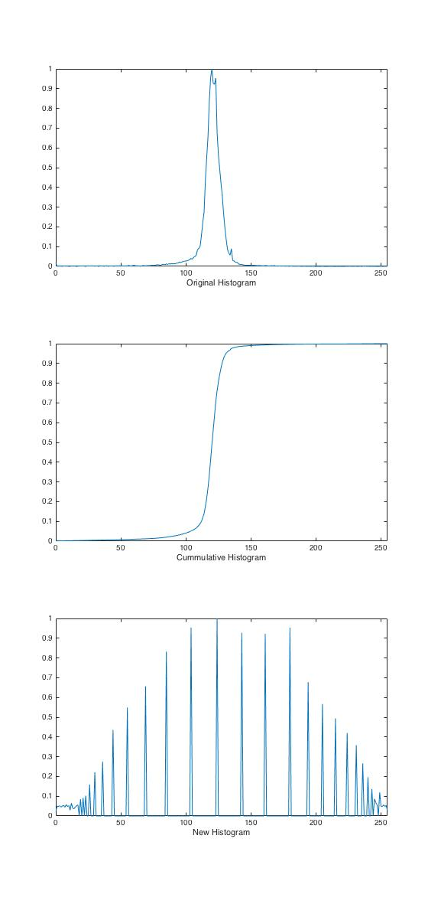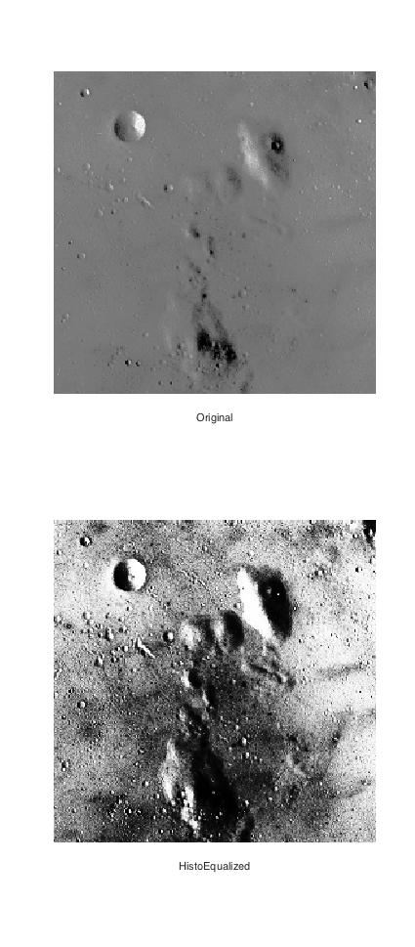

Lighting correction:

Linear fitting and quadratic fitting were both implemented for lighting correction. And in each method, a truncated and scaled version were shown below. The scaled version tends to be dimmer than the truncated one. I added an additional value to the image for visual performance.

